Trinh Bui-Kokkoris
Biography

Trinh Bui-Kokkoris was born in Vietnam. She and her family came to the United States as refugees in 1975 after the Vietnam/American War. She lived in several states with her family and various New York City boroughs before settling in Brooklyn Heights with her daughter, Catrina and husband, Constantine of 25 years. She is a Reiki practitioner and practice various healing methods; and has taught yoga and meditation for over 20 years.

Ms. Bui-Kokkoris is the President and Co-Director of Happy Seniors Social Adult Day Care Center in Canarsie, Brooklyn where she works with senior citizens and adults with developmental disabilities. In 2013, she co-founded a not-for-profit, Vietnam Learning, Arts & Cultural Center (VLACC) to address the needs of immigrants: from organizing free ESL classes to assisting them with filling out documents and referring them to local social services. She is an advocate for victims of Agent Orange, defoliant sprayed over Vietnam during the War where it caused devastating effects on unborn children and adults living in affected regions as well as the environment. Agent Orange has caused birth defects which are affecting fourth generation children as well as US veterans and their descendants. VLACC has raised and will continue to raise funds for programs to support them. She and her husband worked on a documentary (shown on PBS), The Last Ghost of War, which documented the plight of Agent Orange victims in the US and Vietnam.

For her work with the community, Ms. Bui-Kokkoris was invited to be one of the guest honorees in 2020; and was guest speaker in 2018 at the West Nassau Chapter of the National Action Network Dr. King’s Visionary Awards Gala and the Prestigious Women’s Gala Award, respectively. (See attached).

Since late March 2020, during the Coronavirus pandemic, Ms. Bui-Kokkoris redirected the center’s operations along with partnership with and guidance of growingSOUL; and it became one of the central distribution points in central Brooklyn to deliver and giveaway food boxes to distressed communities in Brooklyn. In addition, Happy Seniors Daycare, Inc. was awarded a $10,000 grant through the GingerBread Capital, IFundWomen COVID-19 Relief Grant Program for their work within their community and as minority-women owned business during the pandemic.

She attended Bernard M. Baruch College of the City University of New York on a scholarship where she received a Bachelor of Business Administration degree in Business and Music Management where she performed in musical theater productions, where she met her husband, Constantine Kokkoris.
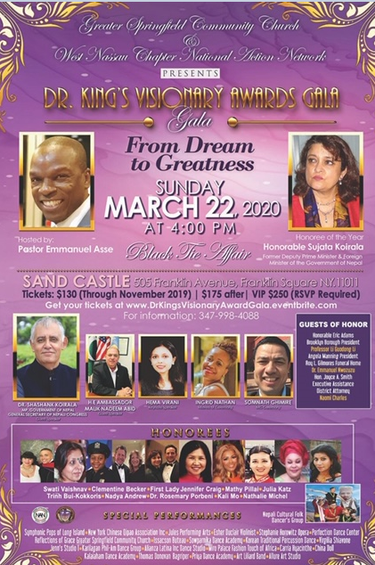
INVITATION LETTER AS GUEST HONOREE
